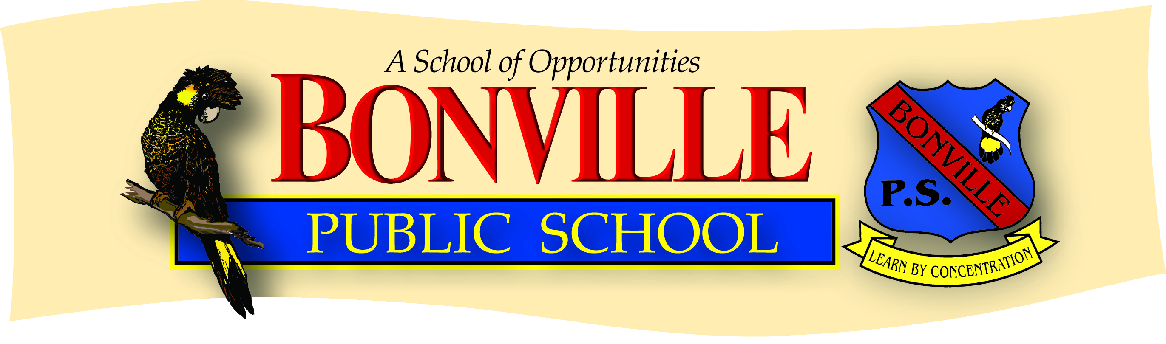

**11 Gleniffer Road, Bonville NSW 2450**

**Phone: (02) 6653 4250 Fax: (02) 6653 4092**

**email: bonville-p.school@det.nsw.edu.au**

**www.bonville-p.schools.nsw.edu.au**

**INTERNATIONAL COMPETITIONS & ASSESSMENTS FOR SCHOOLS (ICAS)**

25th February

Dear parents,

Once again this year we are inviting primary children to enter the Australian Schools Competitions conducted by the University of NSW Educational Testing Centre. Competitions will be for years 3 to 6 and conducted in:

Computer Skills - Tuesday, 21st (Closing date: end of Term 1)  
Science - Wednesday, 5th June (Closing date: Monday 6th May)  
Writing - Monday, 17th June (Closing date: Monday 6th May)  
Spelling - Tuesday, 18th June (Closing date: Monday 6th May)  
English - Wednesday, 31st July (Closing date: Monday 6th May)  
Mathematics - Tuesday, 13th August (Closing date: Monday 6th May)

These competitions can be a stimulating, motivational aid and the results provide valuable information regarding a child’s performance in a wide range of skills. Each student will receive a certificate and a letter with detailed results. To take part you need to pay the entry fee at the school office. The entry fees are: $8.00 for computer, science, english and maths. Spelling is $11.00 and writing is $17.00

Michael Hepi

Principal  
………………………………………………………………………………………………

Please enter ______________________________________ in the following competitions

|  |  |  |  |  |
| --- | --- | --- | --- | --- |
| **COMPUTER ($8.00)** |  |  |  |  |
| **SCIENCE ($8.00)** |  |  |  |  |
| **ENGLISH ($8.00)** |  |  |  |  |
| **WRITING ($17.00)** |  |  |  |  |
| **MATHS ($8.00)** |  |  |  |  |
| **SPELLING ($11.00)** |  |  |  |  |

Please find enclosed $ __________________ to cover costs

Signed: ______________________________ Date: ___________